# **DECLARATION**

I declare that this is my original work and it has never been produced or represented to any examination body by anyone in the institution or any other learning institution therefore I present with faster approval from my supervisor.

**CANDIDATE**

NAME: MUTAI C VICTORIA

DATE: _____________________________ SIGN: ________________________

**SUPERVISOR**

NAME: MR GILBERT

DATE: ______________________________ SIGN: ___________________________

# **DEDICATION**

I dedicate this project to my grandmother Odiah Bamai, my son Myles Kiprop, my aunt, my parents, my siblings, my supervisor Mr. Gilbert, all my friends especially Tevin, Danford and Michael Ngugi.

# **ACKNOWLEDGEMENT**

My heartfelt gratitude goes to my grandmother who gave me her total support during this period. I am forever indebted to you.

I also acknowledge the guidance of God throughout this project, for his provision, protection and faithfulness which he granted me. I am forever indebted to my family for giving me total support during this project period especially during the late nights. To my supervisor, thank you for your support.

# **ABSTRACT**

When renting out our assets, it is very important to keep track of the records and details to do with it. Most of the time we would like to ensure all information are kept intact and don’t get lost or wear out easily. With a manual system, this seems so difficult.

**Legacy Car Rental Information System** is the proposed system; Legacy Car Rental is situated in Pioneer Eldoret. Once the system is completed and implemented it can also be used by other organizations in the future.

The current system at Legacy Car Rental Limited is on manual basis, when one wants to hire a car, their details are taken on books and recorded on files. To book a given vehicle, the customer has to physically go and see the vehicle and its details. After they book, they are given a receipt, asked to leave a copy of their identification and pay the given amount. A copy of the receipt is left for recordkeeping.

Projects experienced in the current system are: - The current system past records are destroyed thus lack of fundamental information to base for future planning of the progress of the business. Access to records is not defined to specify users thus leading access open to any employee in the organization thus are insecure and Delay tactics by employees to attend to other tasks i.e. record of customer information due to paperwork involved in searching of records.

The proposed system is therefore meant to meet the following objectives: - To ensure all transactions are well accounted for and safely stored, to enforce standards and accountability to the company’s personnel, to provide data security and information integrity, eliminating storage space for files; protecting the enterprise information from an unauthorized access; Providing faster access and retrieval of information.

# **LIST OF ABBREVIATION**

SQL – Structured Query Language

RAM – Random Access Memory

CD – Compact Disk

GB – Gigabytes

GHz – Gigahertz

cmd – Command

txt – Text

cmb – Combobox

DFD – Data Flow Diagram

msgBox – Message Box

RDBS – Relational Database Management System

**TABLE OF CONTENTS**

**DECLARATION** i

**DEDICATION** ii

**ACKNOWLEDGEMENT** iii

**ABSTRACT** iv

**LIST OF ABBREVIATION** v

**CHAPTER ONE** 1

**BACKGROUND INFORMATION** 1

**1.0 INTRODUCTION** 1

**1.1** **CURRENT SYSTEM** 1

**1.2** **PROBLEM OF THE CURRENT SYSTEM** 1

**1.3** **PROPOSED SYSTEM** 2

**1.4** **SYSTEM SCOPE** 2

**1.5** **DATA CAPTURE** 2

**1.6** **SYSTEM JUSTIFICATION** 2

**1.7** **SYSTEM REQUIREMENTS** 3

**1.8 OBJECTIVE OF THE SYSTEM** 3

**1.8** **COMPARISON OF THE SYSTEM** 3

**CHAPTER TWO** 5

**2.1 LITERATURE REVIEW** 5

**2.2 OBJECTIVES OF THE PROPOSED SYSTEM** 6

**2.3** **KNOWLEDGE GAP** 6

**CHAPTER THREE** 7

**3.0 INTRODUCTION** 7

**3.1 PROJECT DESIGN** 7

**3.1.0** **FEASIBILITY STUDY** 7

**3.2 DATABASE DESIGN** 8

**3.3 TARGET POPULATION** 9

**3.4 FACT FINDING** 9

**CHAPTER 4** 12

**4.0 SYSTEM DESIGN** 12

**4.1 SYSTEM HIERACHY CHART** 12

**4.2 LOGICAL DESIGN** 12

**CHAPTER 5** 20

**5.0 IMPLEMENTATION** 20

**5.1 INTRODUCTION** 20

**5.2 TESTING PLAN FOR THE PROJECT** 20

**I.** **Desk Checking** 20

**II.** **System Testing** 20

**III.** **Integration Testing** 21

**IV.** **Alpha Testing** 21

**V.** **Beta Testing** 21

**5.3** **CARRYING OUT THE TEST** 21

**5.4** **FILE CONVERSION** 23

**5.5** **USER TRAINING** 24

**CHAPTER 6** 25

**6.0 INTRODUCTION** 25

**6.1 PROBLEMS ENCOUNTERED** 25

**a)** **Research** 25

**b)** **Viruses** 25

**c)** **System failure** 25

**d)** **Power Interruptions** 25

**e)** **Hacking** 25

**f)** **Industrial Espionage** 25

**6.2 SOLUTIONS** 26

**6.3 SECURITY** 26

**6.4 FUTURE IMPROVEMENTS** 26

**6.5 CONCLUSION** 27

**8.0.3 RECOMMENDATION** 27

**INDEX** 28

**APPENDIX I –CODES** 28

**APPENDIX II – HOW TO RUN THE PROGRAM** 32

**APPENDIX III - REFERENCE** 33

# **CHAPTER ONE**

## **BACKGROUND INFORMATION**

### **1.0 INTRODUCTION**

Renting out your important assets can at times be so hard in the current society. A car renting organization is supposed to be so keen on record keeping of the cars they rent. It even is much harder when the records are kept on paper which could easily be damaged or even at times get lost. Losing records is one of the most feared situation in any car rental organization.

Legacy car rental system is the proposed system; Legacy car rental limited is situated in Eldoret. Once the system is complete and implemented it would not only be used at Legacy but also a future enhancement be made to fit other organization offering such services.

### **CURRENT SYSTEM**

The current system at Legacy Car Rental Limited is on manual basis, when one wants to hire a car, their details are taken on books and recorded on files. To book a given vehicle, the customer has to physically go and see the vehicle and its details. After they book, they are given a receipt, asked to leave a copy of their identification and pay the given amount. A copy of the receipt is left for recordkeeping.

### **PROBLEM OF THE CURRENT SYSTEM**

1. The current system past records are destroyed thus lack of fundamental information to base for future planning of the progress of the business.
2. Security: Access to records is not defined to specify users thus leading access to open any employee of the organization.
3. Delay tactics by employees to attend to other tasks i.e. record of customer information due to paperwork involved in searching of records.
4. A lot of space occupied by papers in the office, could otherwise be used for other purpose.
5. Time wastage through searching of records from physical files and cabinets.

### **PROPOSED SYSTEM**

The system was computerized where the process of handling the records of the company would be automated. The system name would be “LEGACY CAR RENTAL INFORMATION SYSTEM”.

### **SYSTEM SCOPE**

The system covered to three major departments i.e. Vehicle, Customer and Booking. Vehicle records entailed details of the vehicles by the system administrator and displaying of the different vehicles. Customer records entailed details of the customer as registered by the staff of Legacy car Rentals and details of the cars they have booked over the period. Booking records entailed records of customer and vehicles that have been booked, it also displays cost of booking payment.

### **DATA CAPTURE**

Raw data was obtained from the source documents collected from the company. The capturing process was done by Legacy staff who also were keying in data in the correct format according to how the system will require on the User Interface (forms). The data wi then be processed into correct information that the system will be able to use for decision making process.

### **SYSTEM JUSTIFICATION**

The proposed system is justified because of the following reasons:

1. Cost: Reduction of cost of stationery and other expenses.
2. Security: The system will be defined and accessed by only specific staff within the organization, thus protecting unauthorized users from accessing vital data
3. Reduction in time spent between accessing, retrieving of records and attending to clients.

### **SYSTEM REQUIREMENTS**

#### **Software Requirements**

To design, document and implement the proposed system the following are required:-

* Windows 7 Professional – Operation system
* Visual basic 6.0 – For coding and design IDE
* SQL- Language for linking with database
* Ms Access - Database Design
* Ms Word - Documentation

#### **Hardware Requirements**

* Pentium IV Processor of 2.6-2.8Ghz speed
* Printer HP D1663 Series
* RAM Memory 1GB-2GB Sizes
* Flash Disk/CDs
* CD ROM/DVD Writer Drives
* Keyboard
* Mouse Optical

### **1.8 OBJECTIVE OF THE SYSTEM**

The proposed system is meant to meet the following objectives:-

1. To ensure all transactions are well accounted for and stored safely.
2. To enforce standards and accountability to the company’s personnel.
3. To provide data security and Information integrity.

### **COMPARISON OF THE SYSTEM**

The proposed system and current system (manual) were compared and some of the advantages and disadvantages were given. These include:-

1. **To continue using the current system**

**Advantages**

* No technical training cost was to be incurred.
* Less expensive.
* It is not risky since employees are used to it.

**Disadvantages**

* No guarantee to data integrity
* Time consuming on the execution of business functions.
* Insecurity – can easily allow unauthorized access.

1. **Develop computerized system**

**Advantages**

* Improved data security.
* Improve speed of operation.
* Availability of backup’s in case of loss of data due hardware or software malfunctioning or destruction by either virus or natural causes.

**Disadvantages**

* Expensive to acquire and maintain.
* The cost will increase as a result of purchase of computer consumables such as Printer toners.

# **CHAPTER TWO**

## **2.1 LITERATURE REVIEW**

Kenya’s government liberalized ICT in 2000, leading to a technological revolution –a triple technological transformation of transport systems, mobile phones, mobile money, and the Internet – which has stimulated home-grown innovation, transforming Kenyans lives. Leading to the study of Legacy Car Rental Information System.

Kenya’s Vision 2030 was initiated during 2008-2012 with a Medium Term Plan based on economic, political, and social pillars: accelerating annual GDP growth to 10% (to make Kenya a middle-income country by 2030) with an issue-based, accountable democratic political system in a cohesive society enjoying equitable development. ICT is noted as already one of the fastest growing sectors, with Vision 2030 prioritizing it as a means towards improved government (e-government strategy) and private sector operations as well as job creation, GDP growth, and social inclusion.

Information and communication technologies (ICT) have considerable importance for car rental ICT system, as they provide access to travel information, planning tools, opportunities to share transport modes, to work at-a-distance, compare transport mode cost, make payment, improve safety and health, and to communicate travel patterns. Over the past decade, there has been massive growth in the availability of transportation ICT, in particular computer application system. There is considerable evidence that ICT has profoundly changed the ways in which transport systems are perceived and used, and mobilities performed; with far-reaching implications for transport mode choices and transport demand. Against this background, the project seeks to conceptualize ICT with relevance for transport systems, thus legacy Car Rental Information Communication System, and to discuss the implications on the use and sustainability of communication information system.

The Opportunity provided to Kenya by Information and communications technology

(ICT) include the promotion of efficiency and productivity. It is the major driver of economic growth and development in the world today, including Kenya. ICT via an affordable network and applications – it is the foundation of a knowledge economy, which promotes innovation, job creation, and exports. A competitive ICT industry is therefore essential for Kenya. Lowering costs and increasing people’s access to ICT. It will reduce transaction costs and increase business efficiency, even for small service firms such as Legacy Car Rentals in Eldoret Town.. It will improve access to information, helping raise educational standards and raising interest in science and public affairs – making workers more accountable while equalizing opportunities both spatially and inter-generationally and helping reduce income inequalities through better job offering.

There are a number of emerging trends in the car rental industry that are chiefly the result of factors such as changes in consumer behavior and increased facilities. However, one factor that has been really impacting the sector is the increase in the number of people who travel by car. Most companies have been capitalizing on this trend by [offering car rental services in airports](https://www.forbes.com/sites/tomiogeron/2013/07/29/airports-are-the-next-big-battleground-in-the-sharing-economy/#1cfa4aff43f0), within towns and even, a lucrative yet highly competitive business landscape.

Another major influence on the sector is the [increased use of information technology](https://www.enterpriseholdings.com/en/press-archive/2014/04/car-rental-business-adapting-to-innovative-technologies-changing-consumer-preferences.html), making tasks such as bookings and reservations so much easier, safer and efficient. And this is not limited to car rental companies. Customers have likewise embraced such technologies owing to the convenience that they offer.

## **2.2 OBJECTIVES OF THE PROPOSED SYSTEM**

1. To eliminate storage space for files
2. Protect the enterprise information from an unauthorized access
3. Provide faster access and retrieval and location of goods in the stores
4. Minimize operational cost
5. Ensure availability of data thus in case there is data loss and failure.

## **KNOWLEDGE GAP**

A liberalized economy, the rise on the use of information communication system, has led to a dynamic and a vibrant economy. Old manual systems used at Legacy Car Rental Services have been slow, there has been need for more staff to handle records, records lost or misplaced when required, delays in service of clients, slowness in regard capturing previous other and other related disadvantages. Thus the need to come up with an efficient car rental information system that will alleviate the need. The research has come up Legacy Car Rental Information System. There is need to carry out more research on the use of information communication systems and its implications on car rental services and transport systems.

# **CHAPTER THREE**

## **3.0 INTRODUCTION**

This chapter discusses in detail how the fact-finding exercises were conducted for the determination of the information system requirements. The scope of functional influenced the method of analysis.

## **3.1 PROJECT DESIGN**

### **3.1.0 FEASIBILITY STUDY**

This study analyses the need for and impact of the system and considers different alternatives for acquiring software. Preliminary study determines whether a system would be developed. The following types of feasibility were conducted:-

#### **Economic Feasibility**

The cost and benefit analysis of the system were conducted. All feasibility assessment of an information system should include cost and benefit analysis. This identifies both tangible and intangible benefits and costs. This involved staffs saving time, system saving, development saving and even time consuming.

#### **Social Feasibility**

Entails the reaction of the organizations personnel who were to be affected by the proposed system either directly or indirectly.

#### **Operational Feasibility**

Involves the determination that the system will be able to perform designated functions with the existing organizational environment, current personnel and existing procedures, the time estimates when the system is adopted or whether the system is constantly in use. The staff of Legacy car rental, have basic knowledge on computer. Minimum training will be done as part of system implementation.

## **3.2 DATABASE DESIGN**

Legacy Car Rental Information Systems includes five tables which are listed below:-

1. Fig 1 - Admin Table

|  |  |
| --- | --- |
| **Field** | **Type** |
| username | Text |
| password | Text |

1. Fig 2 - User Table

|  |  |
| --- | --- |
| **Field** | **Type** |
| Username | Text |
| Password | Text |

1. Fig 3 - Vehicle

|  |  |
| --- | --- |
| **Field** | **Type** |
| Make | Text |
| Plate | Text |
| capacity | Integer |
| Size | Text |
| Price | Integer |

1. Clients

|  |  |
| --- | --- |
| **Field** | **Type** |
| Client_name | Text |
| Passport_no | Text |
| address | Text |
| Phone_no | Text |
| Area | Text |
| dl_no | Text |

1. Book Table

|  |  |
| --- | --- |
| **Field** | **Type** |
| Price | Integer |
| Total | Integer |
| Pass_no | Text |
| Plate | Text |
| Pick | Date/Time |
| return | Date/Time |
| number | Integer |

## **3.3 TARGET POPULATION**

* The target population include all :-

1. Owner, including management of LEGACY CAR RENTAL LIMITED.
2. The Employees
3. Clients of LEGACY CAR RENTAL LIMITED

## **3.4 FACT FINDING**

This was carried out to obtain fundamental information suitable for the design of the proposed system.

The best methods employed were interviews, questionnaires and inspection of records. The groups to be interviewed are:

1. Management
2. Receptionist
3. Customers

#### **Interviews**

Interviews entailed asking the specific users of the system questions pertaining the problems under investigation. The interviewer then got answers from the data for the fact-finding mission.

Interviews split into two - the structured and unstructured interviews. System analyst used structured interview where it included the questions well planned and written out in advance. The questions and the average answers which were obtained from users were as follows:

* How does a single transaction process take in a busy day (meaning more clients)?

**Answer:** About half an hour

* Do you have to keep clients waiting when recording or retrieving their personal details?

**Answer:** Yes

* How do you check for the availability of specific client information in Legacy?

**Answer:** Search through the files

* Will you feel comfortable if the new system is developed to solve some of these problems?

**Answer:** Definitely yes.

##### **Advantages**

1. Efficient: - You can get the answers of users by looking at their facial expressions.
2. Face to face interviews save on time.

#### **Record Inspection**

Every organization keeps records of its transactions for both reference and performance evaluation. These documents includes memos, organizational structure, manuals, forms, policy statements and so on. The documents the researcher went through were primary data made of customer records, vehicle records and booking transactions.

##### **Advantages**

1. Documents were placed at a clean, safe place, they told you how things were supposed to be ran.
2. They also provided areas to pursue further for more details.

#### **Questionnaires**

A questionnaire is useful fact-finding technique for gathering information from a large group of people when you want to get around interviewing everyone.

The questionnaires used were sent to regular customers with a combination of the following questions

***Sample Questionnaire:***

**TICK WHERE APPROPRIATE**

1. Do you feel the computerized system will cause more errors?

Yes ( ) No ( )

1. Would you like to use computerized system when placing your orders?

Yes ( ) No ( )

1. Would you like to be served fast and appropriate?

Yes ( ) No ( )

##### **Advantages**

1. More sincere responses are given.
2. You can email a questionnaire instead of being their physically.

After gathering of the information the analysis was done. Modelling tools were used. The modelling tools enable the analyst to present graphically or pictorially represent a system being analyzed. Examples of modelling tools include dataflow diagrams, system flowcharts and decision tables.

# **CHAPTER 4**

## **4.0 SYSTEM DESIGN**

System design generally entails the process of developing a system. Developed system has to meet the user requirements specified in the system design stage. That is the design of the system should produce the desired results. This stage involves designing inputs, the system logic, determining control and audit.

## **4.1 SYSTEM HIERACHY CHART**

This chapter helps to understand the steps followed during the development period.

Once the system is loaded, the system prompts the user to login as either the Administrator or the user. If the user chooses administrator, they are prompted to login. If the correct login details are entered, a form appears where the administrator is left to choose the function.

If the user chooses user login, they are prompted to login. If the correct login details are entered, a form appears that gives the system user the different options.

## **4.2 LOGICAL DESIGN**

Logical design gives design model of user requirements from the beginning of system development. Logical design was shown to the user and organizations management for approval and suggestion. Thus, it involves successive refinement of the model until it meets user requirements. The refinement normally starts with the output of the system way back via the file (stored data) to input and procedures taking into account the objectives and constraint the system has to accommodate. Design can be in form of flowcharts or dataflow diagrams

#### **FLOWCHART DIAGRAMS**

1. Login

Enter Username and Password

Is username and Password??

NO

YES

Login Successful

1. Add Records

Enter Records

SAVE

1. Delete Records

CLICK DELETE

DELETE SUCCESSFUL

#### **4.2.2 INPUT DESIGN**

Raw data is entered to the system for processing. The data is obtained from the source document. The system accepts the input via the form from the keyboard.

The purpose of designing the input is to make data entry easier and free from errors. The data entered are validated before they are saved to the system. Legacy Car Rental Information System uses forms as its input method. The following are considered in the design of the inputs:-

* Format of the input data.
* Field specification of each field.
* Field sequence must match that of the source document.

#### **INPUT SCREEN DESIGN**

These include the forms used to collect data from the user. To design input screen, the following were considered:

* Error messages from validation and verification of data.
* Use of easy to learn and consistence terms.
* Spacing of fields to avoid eyestrain

The following are the input designs for the system:-

**HOME SCREEN**

This is the entry point to the system. Here a system user decides whether to login as user or administrator.

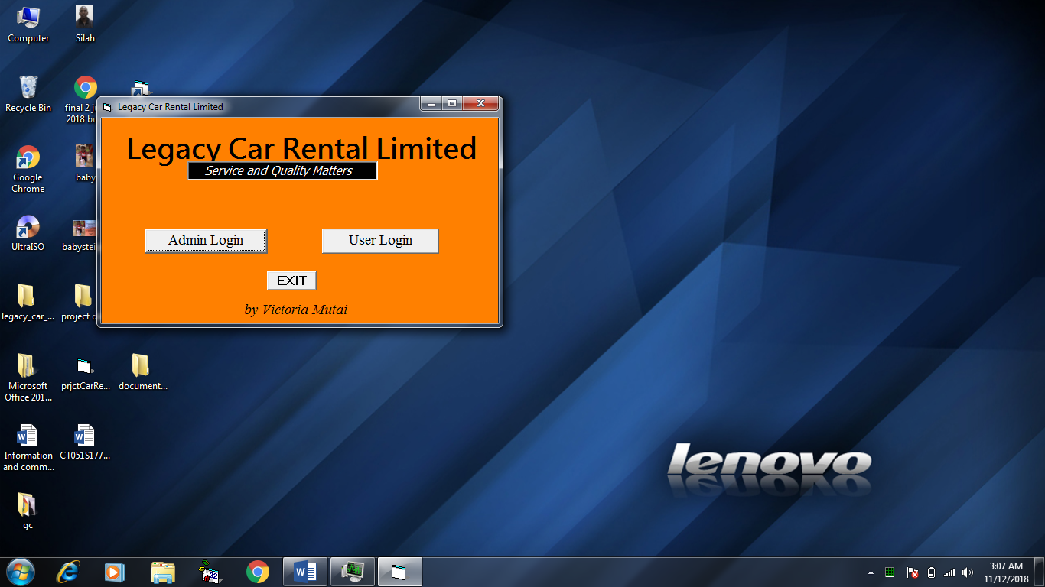

**LOGIN SCREEN**

The login screen allows the user into the system on condition the right credentials are used.

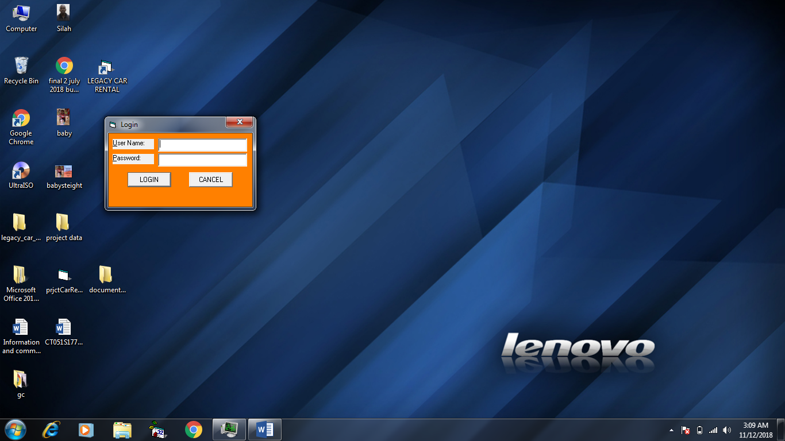

**ADMIN MENU**

Once logged in as Admin, this menu appears that allows an administrator to choose what they want to do.

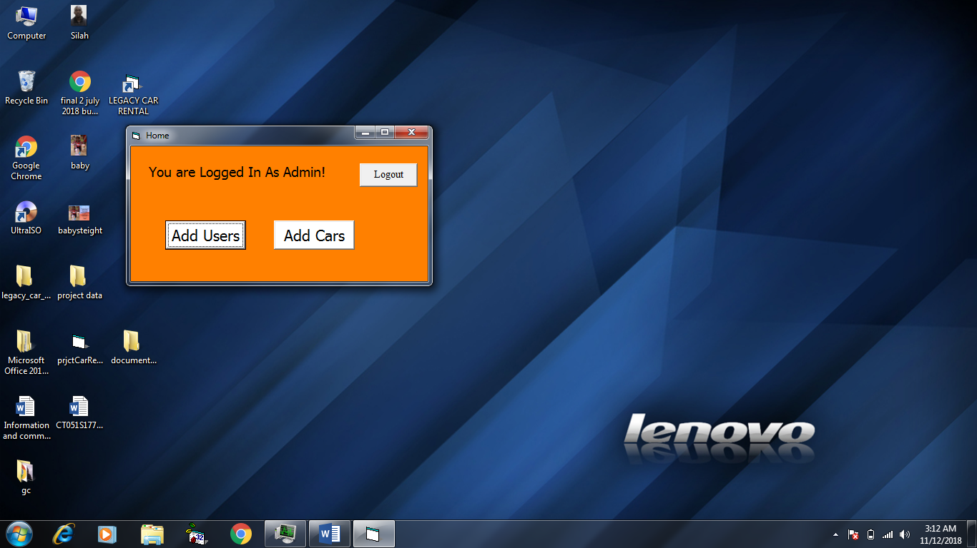

**ADD CARS**

Used to enter information on the car into the car rental system. This can only be done by the administrator.

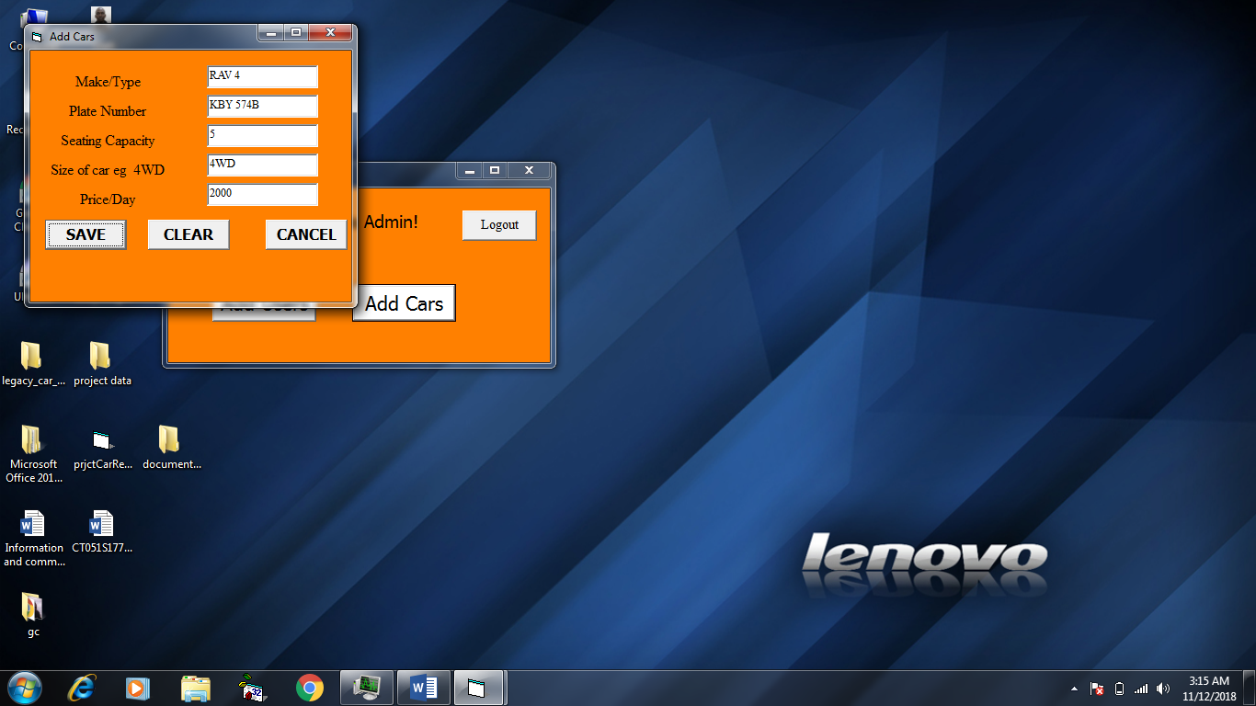

**ADD USERS (Employees)**

Used to enter information on the user into the car rental system. This can only be done by the administrator. This information is basically login details of the user.

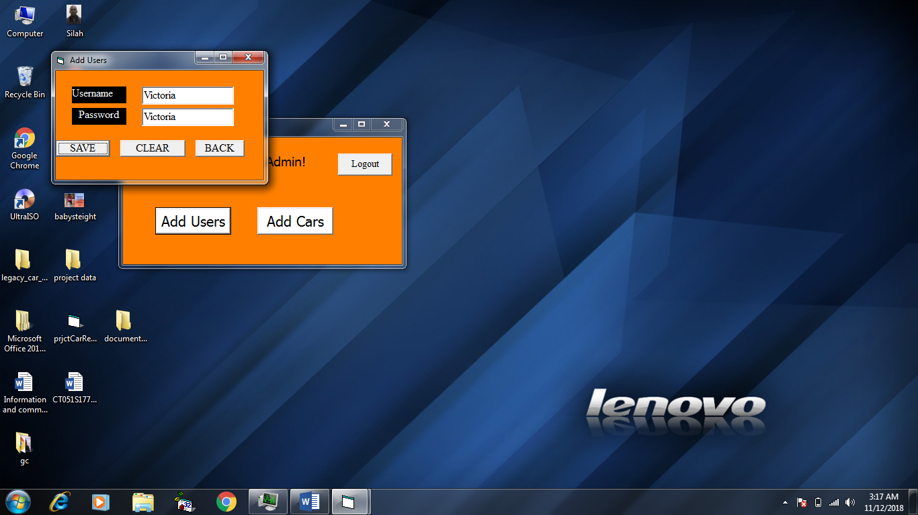

**USER MENU**

Once logged in as user, this menu appears that allows a system user to choose what they want to do.

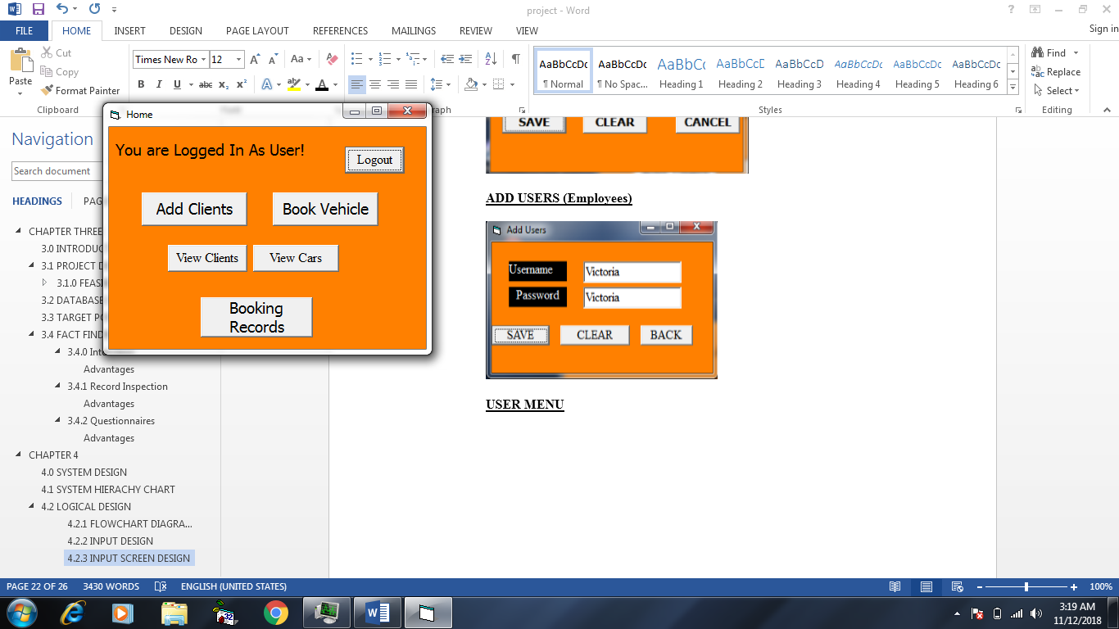

**ADD CLIENTS**

Used to enter information on the different clients into the car rental system. This is done by the user.

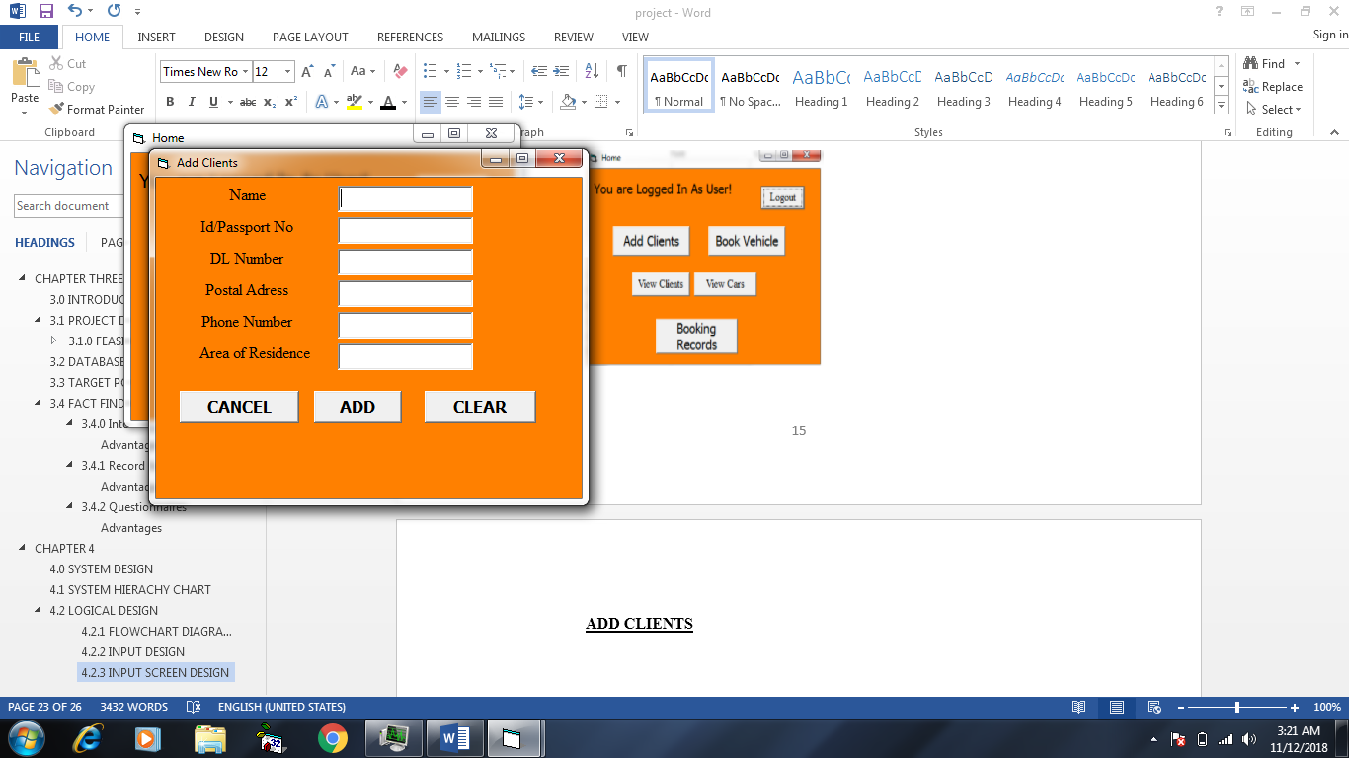

**BOOK VEHICLES**

This is the form used for booking vehicles.

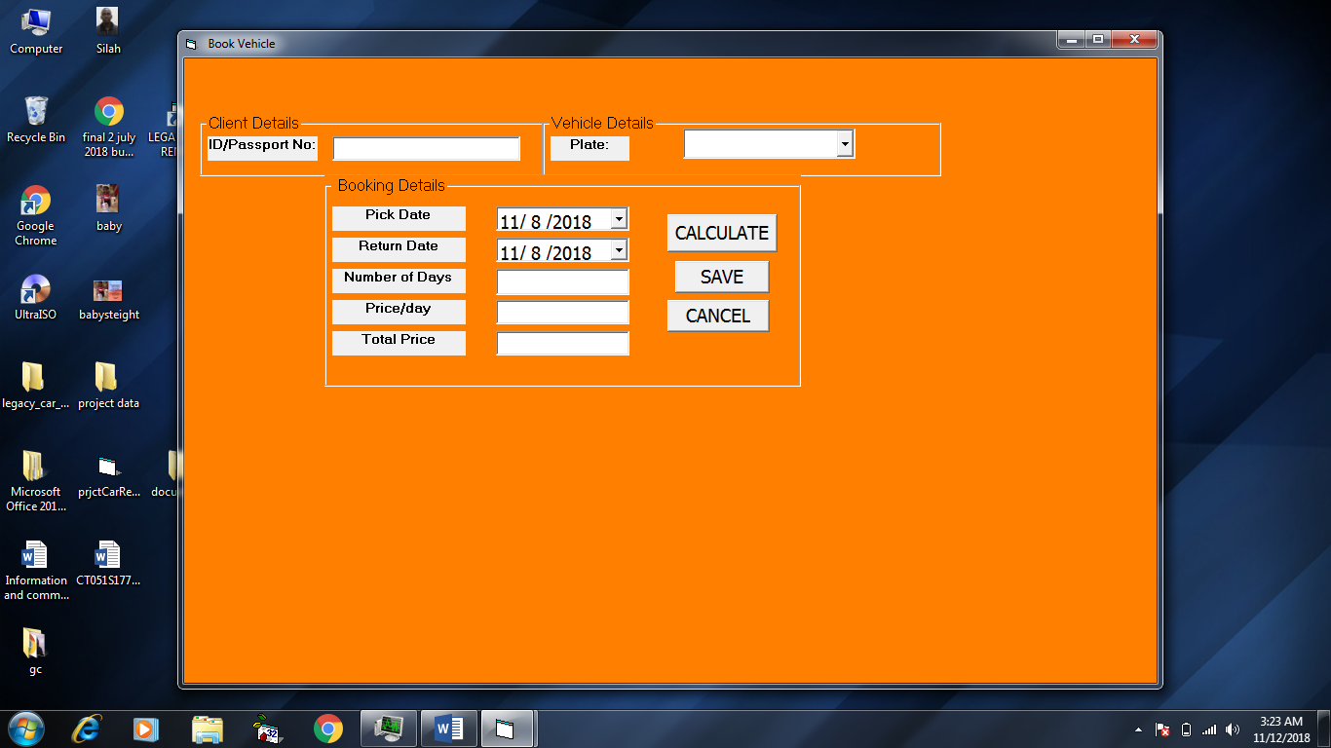

**VIEW CLIENTS**

This form is used to view client information.

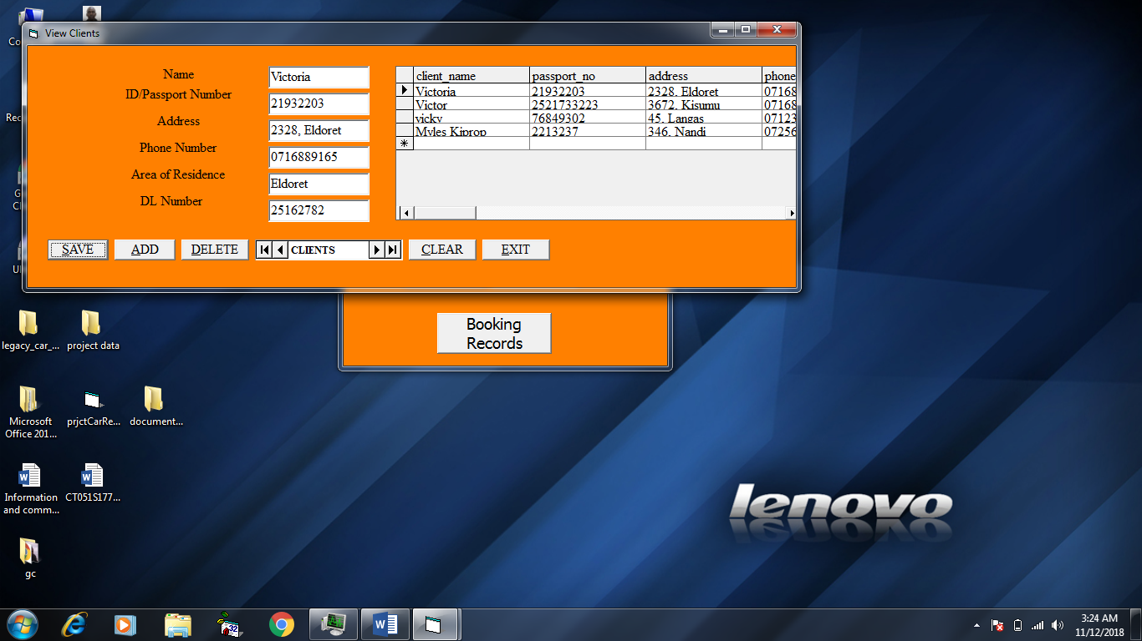

**VIEW CARS**

This form is used to view vehicle information.

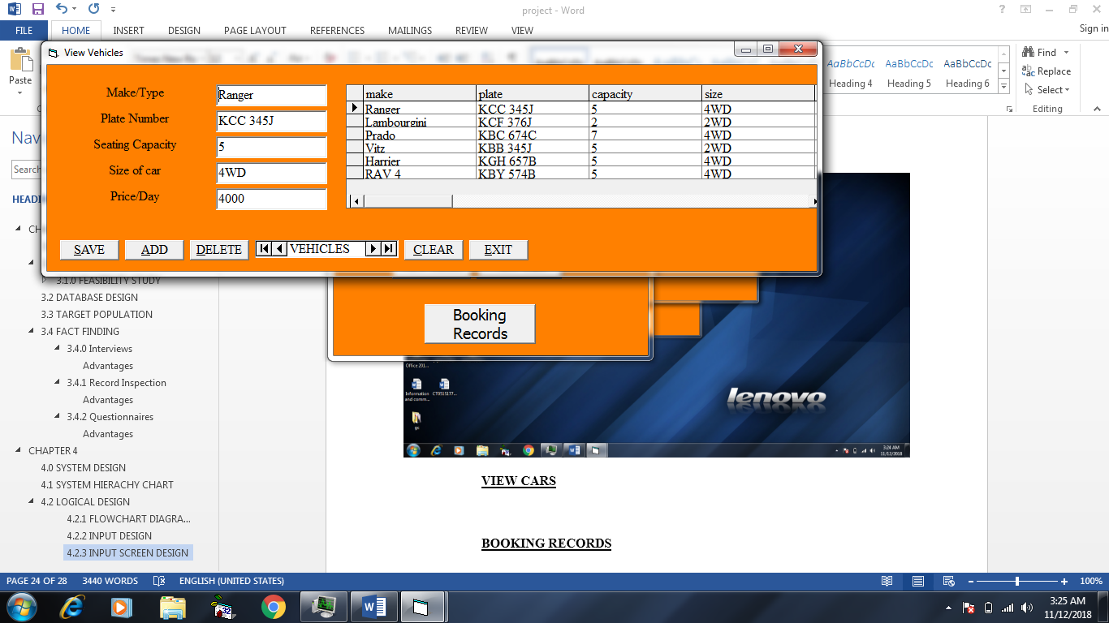

**BOOKING RECORDS**

This form is used to view information on the booked vehicles.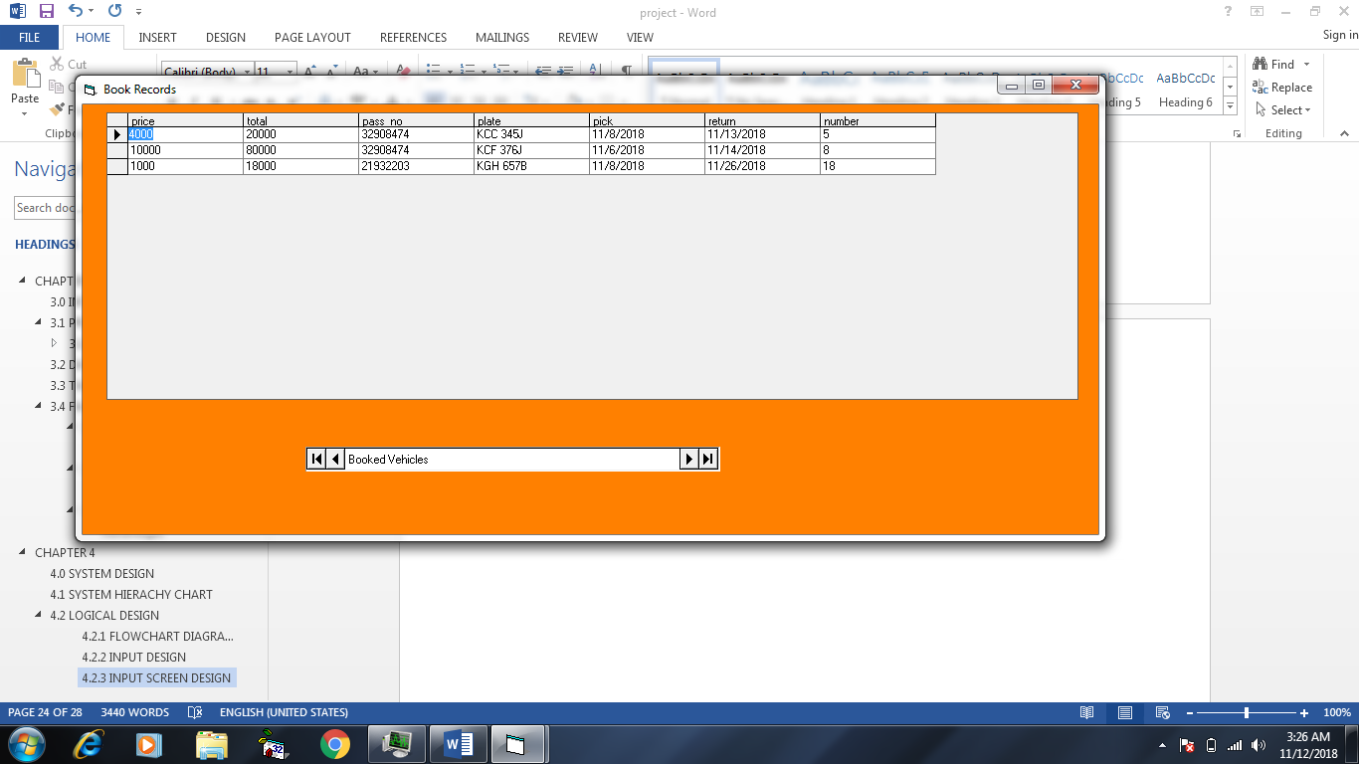

# **CHAPTER 5**

## **5.0 IMPLEMENTATION**

## **5.1 INTRODUCTION**

Implementation entails putting the new system into use. This implementation phase is under taken upon approval of the system specification. This stage involves program coding, testing and training of users. The fully documented operational system that meets the requirements specified in design process is fully put into use.

## **5.2 TESTING PLAN FOR THE PROJECT**

Testing is done to ensure the system functions as expected and meets the desired objective meant. The system is first tested individually then testing the system as an entity done to ensure that they are compatible and functional according to design specification.

A system should not be operational until it has been proven error free and the users are familiar with its operation. All new hardware procedure manual, and all system interfaces should be tested to ensure that they meet the required standards to the design expected by the users and management.

System testing was carried out using the following techniques:

### **Desk Checking**

A testing technique where program code is sequentially executed manually by a reviewer with a pencil and paper.

### **System Testing**

Whole system code and programs are compiled for testing purposes. This is done after the analyst has tested each part of the system individually. The whole system must be tested to ensure that it functions as a whole unit.

System testing consists of the following phases:-

1. Single run testing - The system is tested over a single pass of data.
2. User acceptance – A process of system testing in an environment where it will eventually be used after which users sign off on the system and accept it.

### **Integration Testing**

It’s the process of bringing together all the modules of the program for testing purposes. It is a gradual process.

### **Alpha Testing**

This is where the user tests the system using simulated data.

### **Beta Testing**

This is where the user tests the completed information system using real data.

Personnel involved in the system testing

In testing of the system, personnel from different departments are involved. This improves the confidence of the employees, also ensures that an error free system is implemented. Each group has special contribution, and hence ensuring the system meets departmental objectives.

1. Programmer
2. Systems Analyst
3. Operations Manager
4. User Department

## **CARRYING OUT THE TEST**

This involves:-

* Accuracy of the system, that is to ensure that the system is error free.
* Reliability: this is to ensure that the system produces expected results.
* Security and Integrity: This is to ensure that unauthorized personnel cannot access the system.
* Speed of processing data and report production.

Testing is to be carried out according to the test plan produced by the system analyst. First, unit testing is done. This involves testing separate components of the system as they are produced.

Secondly, integrated testing is done which entails testing the whole program once it is in the final stage. Thirdly, the system testing is performed where the user determines what the system is expected to do.

Below shows the table structure of each field item in the database:

**SAMPLE TEST DATA**

**Admin login table**

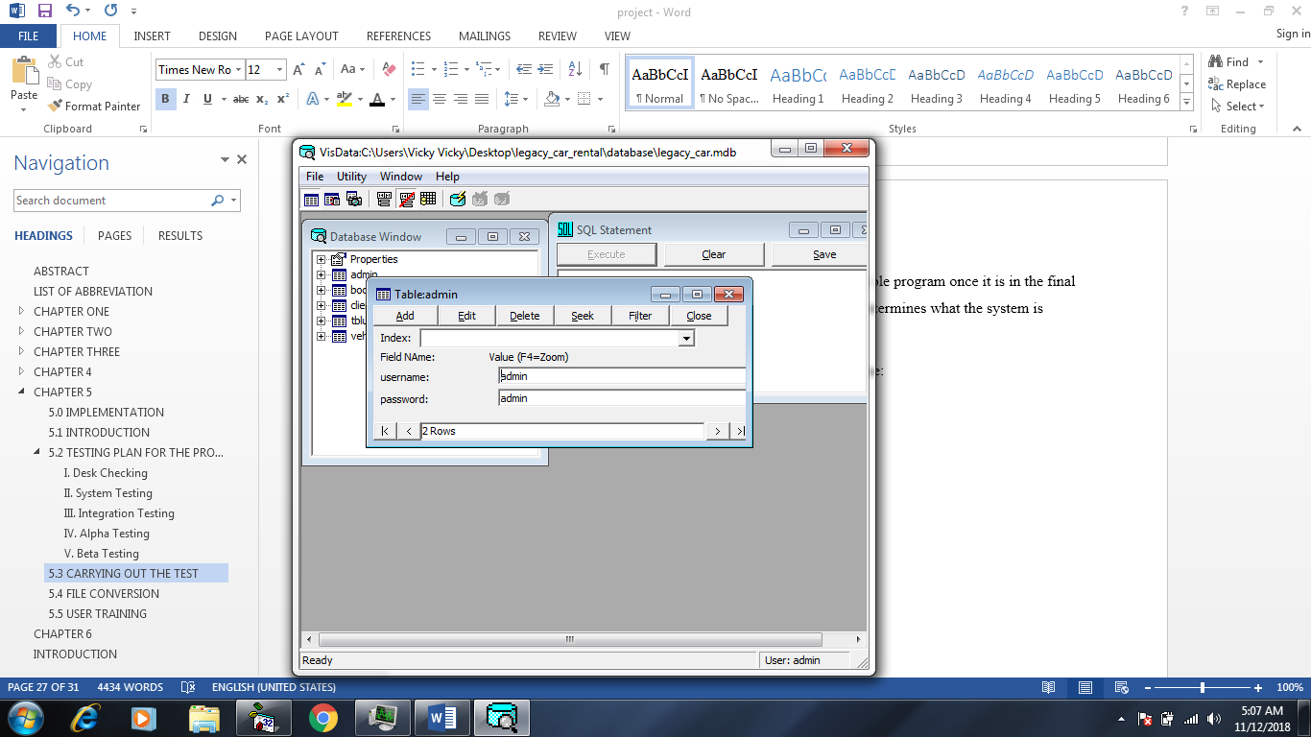

**User login table**



**Vehicles table**

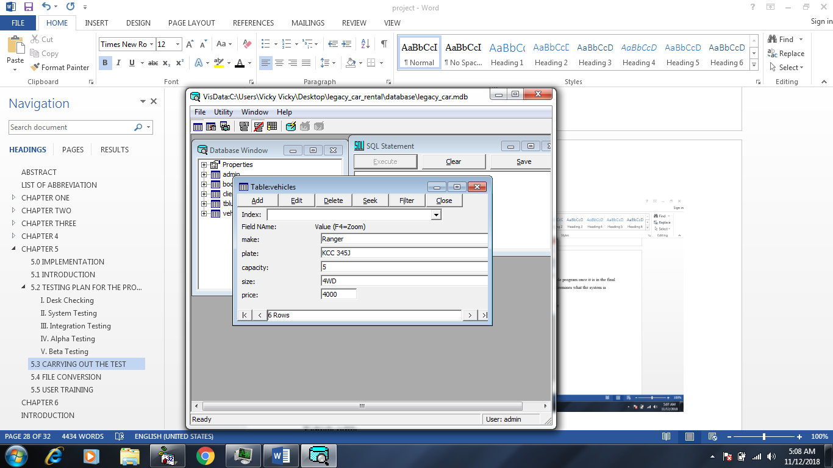

**Clients table**

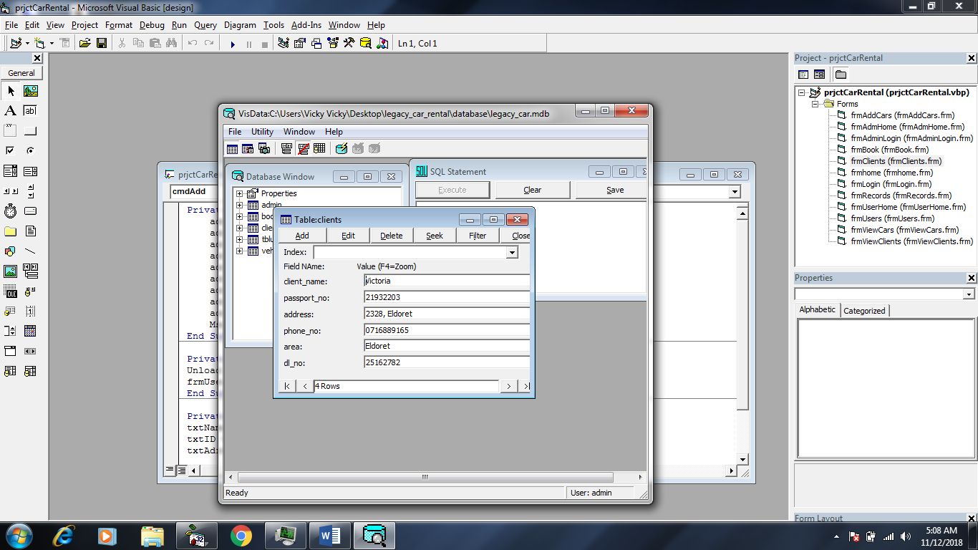

**Book Vehicle table**

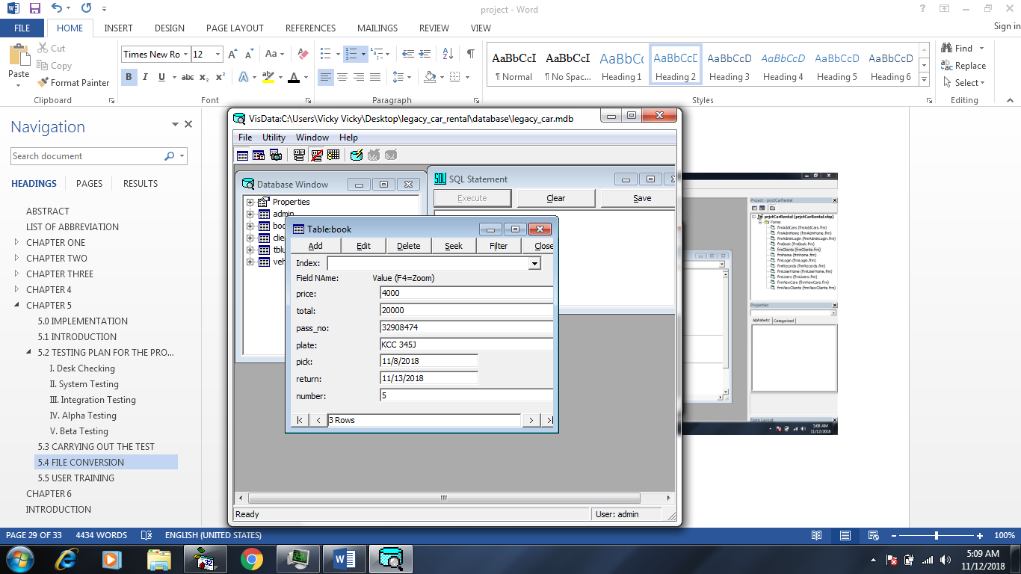

## **FILE CONVERSION**

This is the process of changing the existing files into the form where it can be used by the new system.

The files to be converted include master files, file records and reference file records. When a new system is to be implemented, it is likely that the master files either do not exist or are not organized as required by the new system.

Before the new system becomes operational, the master files must be created. This can be a difficult task which involves file conversion and it is also expensive. This is why both the old and new are run concurrently for a specified period of time. The resultant output from the system are then compared and any differences are reconciled. Though the operation using this method is expensive and time consuming, it has the strength of no risk and also provides the opportunity of training of the personnel of the new system.

The implementation controls of the system were also observed and tested to ensure they were functioning as it was required in the requirements specification.

When the new system performs to satisfaction, this system completely replaces the old system.

## **USER TRAINING**

With the introduction of the new system, it was necessary to train and retrain in case of those involved in the parallel conversion, members of staff of all departments concerned on how to operate the new system.

All staff should be trained, this will involve the user department and any other affected department.

The method used to train users are, on job training which is most appropriate in this case as the individual is assigned a simple task and given specific instructions on what to be done and how it should be done.

# **CHAPTER 6**

## **6.0 INTRODUCTION**

This chapter basically entails problems encountered during the process of analysis and development of the new system, its solutions and future improvements. It also entails recommendations and conclusions.

## **6.1 PROBLEMS ENCOUNTERED**

The following were the problems encountered during the system development:

### **Research**

Basically time consuming and tedious job. The enterprise problems and the need for the new system could not be solved based on understanding/knowledge of the system analyst. The researcher has to research and design the system based specification and requirements of the user of the system and the management.

### **Viruses**

These are coded programs which invades themselves to the system main software or programs corrupting the functionality of thee computer system. They are spread through the external storage media i.e. flash disks and form of storage media from one computer to the other.

### **System failure**

The breakdown of the system that is caused either by viruses or over commanding computer. It can also be caused by power failure or the hardware failure.

### **Power Interruptions**

Cause or occurs when computer power system fails or disrupted by the main power supply system.

### **Hacking**

This is the unauthorized access and modification or destruction of organizations data or computer file for malicious gain by unauthorized users.

### **Industrial Espionage**

These are damages caused by the competitor to the information system of the organization.

## **6.2 SOLUTIONS**

* Scanning (Anti-virus programs) using strong anti-virus software
* Employ steel doors for security
* Employ guards to provide security in computer buildings.
* Vet the use of storage media before using it with the computer.
* Vet all personnel entering data processing department.
* Avoid using pirated software.
* Provide access locks to computer systems by introducing passwords and user name for access by authorized personnel or staff.

## **6.3 SECURITY**

Computer security regard to safeguarding the computer and its related devices from the risk of damage or fraud. These risks are as follows: - Stealing of hardware, hacking, cracking and industrial espionage.

#### **Software Security**

This can be in the form where the individual gains access to the system resources e.g. files. System protection can be done by designing a password into the system to proven unauthorized access to unspecified persons.

#### **Physical Security**

It entails taking care of the computer systems, hardware and its peripherals from damages and fraud such as theft or natural disaster e.g. floods, earthquakes.

#### **Amendment Security**

This precaution taken against unauthorized modification of the computer system.

## **6.4 FUTURE IMPROVEMENTS**

The system has been developed with the understanding that it could accommodate future improvements i.e. online processing and government incentives like tax returns, implementing lipa na mpesa. Definitely, the enterprise will be working using the new system as all the specifications has been made and room made for future improvements.

## **6.5 CONCLUSION**

There are a number of factors that helped to determine the degree of success of a computerized system. Some of the factors are the enactment of organizational change process, working with stakeholders who are co-opetrative and also proper implementation planning. To the analysts point of view, the new computerized system after proper development and implementation it has come out successfully by accomplishing all the original objectives designed for during its proposal. The new Legacy Car Rental can be judged in terms of increased in the speed of operations and processing data.

When you compare the old and this new system you realize that the new system is more productive and it meets specifications that were spelled out by the management. The new system has also satisfied the user requirements as expected.

## **8.0.3 RECOMMENDATION**

I hereby recommend the candidate system to Legacy Car Rental Limited. It is a suitable system and comes at a time when Legacy Car Rental Limited really deserves the change. The system is able to solve the said weaknesses and improve the system performance in terms of efficiency; profits/present value will increase as per NPV and productivity.

# **INDEX**

# **APPENDIX I –CODES**

**Main Form**

Private Sub cmdAdmin_Click()

frmAdminLogin.Show

Unload Me

End Sub

Private Sub cmdExit_Click()

End

End Sub

Private Sub cmduser_Click()

frmLogin.Show

Unload Me

End Sub

Private Sub cmdUsers_Click()

frmClients.Show

Unload Me

End Sub

Private Sub Command1_Click()

frmBook.Show

End Sub

**Login Form**

Option Explicit

Public LoginSucceeded As Boolean

Private Sub cmdCancel_Click()

'set the global var to false

'to denote a failed login

LoginSucceeded = False

Me.Hide

frmhome.Show

End Sub

Private Sub cmdOK_Click()

loginAdo.RecordSource = "select * from tbluser where username='" + txtUserName.Text + "' and password='" + txtPassword.Text + "'"

loginAdo.Refresh

If loginAdo.Recordset.EOF Then

MsgBox "Login failed,Try Again..!!!", vbCritical, "Please Enter correct Username and Password"

Else

frmUserHome.Show

Unload Me

End If

End Sub

**User Menu Form**

Private Sub cmdBooked_Click()

frmRecords.Show

End Sub

Private Sub cmdBookVehicles_Click()

frmBook.Show

End Sub

Private Sub cmdCars_Click()

frmViewCars.Show

End Sub

Private Sub cmdClient_Click()

frmClients.Show

End Sub

Private Sub cmdClients_Click()

frmViewClients.Show

End Sub

Private Sub cmdLogout_Click()

frmhome.Show

Unload Me

End Sub

**Add clients form**

Private Sub cmdAdd_Click()

addAdo.Refresh

addAdo.Recordset.AddNew

addAdo.Recordset.Fields("client_name") = txtName

addAdo.Recordset.Fields("passport_no") = txtID

addAdo.Recordset.Fields("address") = txtAdress

addAdo.Recordset.Fields("phone_no") = txtPhone

addAdo.Recordset.Fields("area") = txtArea

addAdo.Recordset.Fields("dl_no") = txtDL

addAdo.Recordset.Update

MsgBox "New Client Added"

End Sub

Private Sub cmdCancel_Click()

Unload Me

frmUserHome.Show

End Sub

Private Sub cmdClear_Click()

txtName = ""

txtID = ""

txtAdress = ""

txtPhone = ""

txtArea = ""

txtDL = ""

End Sub

**Add Cars**

Private Sub cmdCancel_Click()

Unload Me

End Sub

Private Sub cmdClear_Click()

txtMake = ""

txtPlate = ""

txtCapacity = ""

txtSize = ""

txtPrice = ""

End Sub

Private Sub cmdSave_Click()

carAdo.Refresh

carAdo.Recordset.AddNew

carAdo.Recordset.Fields("make") = txtMake

carAdo.Recordset.Fields("plate") = txtPlate

carAdo.Recordset.Fields("capacity") = txtCapacity

carAdo.Recordset.Fields("size") = txtSize

carAdo.Recordset.Fields("price") = txtPrice

carAdo.Recordset.Update

MsgBox "New Vehicle Added"

End Sub

**Book Vehicles**

Private Sub cmdCalc_Click()

txtNumber = (DateValue(dtreturn) - DateValue(dtpick))

If txtNumber = 0 Then txtNumber = 1

txtTotal(0) = txtNumber * txtPerDay(0)

End Sub

Private Sub cmdCancel_Click()

Unload Me

End Sub

Private Sub cmdSave_Click()

bookAdo.Refresh

bookAdo.Recordset.AddNew

bookAdo.Recordset.Fields("pass_no") = txtPass

bookAdo.Recordset.Fields("plate") = Combo1

bookAdo.Recordset.Fields("pick") = dtpick

bookAdo.Recordset.Fields("return") = dtreturn

bookAdo.Recordset.Fields("number") = txtNumber

bookAdo.Recordset.Fields("price") = txtPerDay(0)

bookAdo.Recordset.Fields("total") = txtTotal(0)

bookAdo.Recordset.Update

MsgBox "Car Booked"

If txtPass = "" And Combo1 = "" Then

MsgBox ("Cannot Save empty record")

End If

End Sub

Private Sub Combo1_Click()

If Not Combo1.Text = "" Then

carAdo.RecordSource = "select distinct price from vehicles where vehicles.plate = '" & Combo1.Text & "';"

carAdo.Refresh

Set txtPerDay(0).DataSource = carAdo

txtPerDay(0).Refresh

End If

End Sub

Private Sub Form_Load()

carAdo.Refresh

With carAdo.Recordset

Do Until .EOF

Combo1.AddItem ![plate]

.MoveNext

Loop

End With

End Sub

# **APPENDIX II – HOW TO RUN THE PROGRAM**

The program of this project which is Legacy Car Rental Information System is stored in a CD-ROM and can be run in the following steps:

1. Insert the CD-ROM into CD-ROM drive of the computer, then access it from my Computer by double clicking the drive icon if it does not come up automatically.
2. Once the CD-ROM, you will see program files.
3. Click on executable file called setup, this will install the software to your computer.
4. Once installed, you can either login as admin or as user.

The login details for admin is – username – **admin** and password – **admin**

The login details for user is – username – **user** and password - **user**

# **APPENDIX III - REFERENCE**

* Salemi N. A (1999) System Theory Analysis and Design.
* Mil pough B. (2000) Programming in Visual Basic.
* Laundon K. C. (2001). Management Information System.
* DR. J. Onunga (1999). Introduction to Microcomputer and programming
* According to Huawei ICT, solutions provider at a Broaderway Forum for Kenya held the sidelines of the Cyber Security East Africa Conference:http://www.itnewsafrica.com/2012/12/broadband-key-to-kenyas-ict-master-plan/
* Apoyo Consultoria, “Study on ICT Access Gaps in Kenya: Final Report”, prepared for the Communications Commission of Kenya (CCK), April 2011.
* “Kenya Vision 2030”, Ministry of State Planning, National Development, and Vision 2030, 2003.
* “CCK Strategic Plan, 2008-2013”, Communications Commission of Kenya (CCK), 2008. *(PDF) ICT and transport behavior: A conceptual review*. Available from: <https://www.researchgate.net/publication/317393234_ICT_and_transport_behavior_A_conceptual_review> [accessed Oct 22 2018].